Press release: For immediate distribution
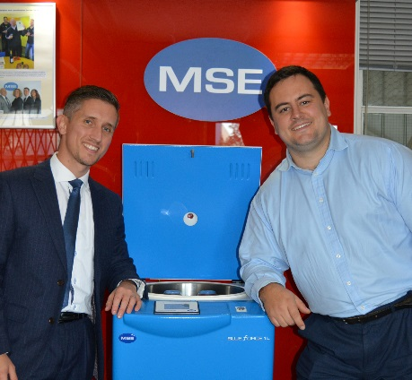
British manufacturers mobilising to ensure they are not overlooked during Brexit negotiations
Alex Henderson (L) & James Bradshaw (R) with MSE British made centrifuge.
A group of British manufacturers are looking to persuade Theresa May that the future strength of the UK economy is safe in their hands post Brexit. The newly formed British Manufacturing Lobby (BML) aims to secure a meeting with the Prime Minister ahead of the Brexit talks to ensure the ailing sector is in a stronger position both domestically and abroad following the UK’s exit from Europe.
BML, currently being spearheaded by prominent British manufacturing campaigner James Bradshaw and Alex Henderson, Managing Director of the London based, laboratory centrifuge manufacturer MSE, said the lobby group would give an independent voice to British manufacturers.
They said the newly-formed organisation would press for action on many issues that have raised concerns within the ailing British manufacturing sector, including strengthening their calls to reform EU tending rules and open up international markets to export.
Bradshaw, who has gained significant media attention in recent years with his campaign to raise awareness of British made goods and pens an influential blog, says “manufacturers feel let down by current Government policy and have done for years. Whatever, your political views, we need to see Brexit as an opportunity to sell our goods further than before and unbind ourselves from certain restrictions the EU places on us both domestically and internationally.”
More than 20 business leaders from across the UK will meet in November to formally appoint a new board for the lobby group. The aim will be to secure an audience with the Prime Minister to highlight the opportunities for change which are much needed in this sector.
For decades, the UK manufacturing industry has seen a steady decline compared to the relative growth experienced by other EU countries, such as Germany, The Netherlands and France. Henderson, whose company manufactures medical equipment in London and exports internationally, suggests that British manufacturing could rival its European counterparts if the UK government emphasised support for British made goods. He continues “Government funded organisations such as the NHS should have a preference to buy locally made British products, where the price and quality is the same or better. Historically, our government has been unable to do this due to EU competition regulations.”
The group are calling for equally passionate manufacturing business leaders to join them for their meeting on the 29th November 2016 to help form the lobby’s charter and register your interest via www.britishfamily.co.uk/BML.
For comment or press enquiries please contact James Bradshaw on 0772 5940351 or James@britishfamily.co.uk or Alex Henderson 0208 663 4610 alex.henderson@mseuk.co.uk. Images available from https://goo.gl/photos/i5tGVDssnVJk4d3LA
James Bradshaw and his family gained international attention in 2013 with their campaign to survive as a family for 1 year buying only British goods. He has since helped found the Made in Britain Campaign and writes a successful blog promoting British makers.
Alex Henderson is 2nd generation in his family business that has been manufacturing medical centrifuges, safety cabinets and isolators in the UK for over 80 years.

